Report on 2014 NBI benchmarks

Mireille Schneider, Otto Asunta, Thomas Johnson

This report summarizes the NBI benchmark activity that has been carried out in 2014 using the WPCD deposition and Fokker-Planck codes, dedicated to NBI modelling. All results presented here are performed using input and output stored as CPOs in the UAL (Universal Access Layer). The original plasma profiles are taken from JET and ASDEX-Upgrade, although none of the modelling performed aims at validating codes against a specific discharge. Instead this benchmark provides code verification through code-code comparisons. The benchmark presented below is a first step towards a code verification procedure to be developed further in 2015.

Presently involved codes:

NBI modelling is carried out in two steps:
- Deposition: In the first step, the injection of fast neutrals into the plasma is modeled. This step ends when a neutral is either ionized or hits a wall surface. This calculation provides both wall loads and a source of ions inside the plasma, i.e. an ion deposition rate to be used in ion Fokker-Planck modelling. The available codes are:
  - BBNBI (Contact person: Otto Asunta)
  - NEMO (Contact person: Mireille Schneider)
- Ion Fokker-Planck: In the second step, a Fokker-Planck equation is solved, including an ion deposition rate. The available codes are:
  - ASCOT (Contact persons: Otto Asunta, Seppo Sipilä)
  - NBISIM (Contact person: Thomas Johnson)
  - RISK (Contact person: Mireille Schneider)
  - SPOT (Contact person: Mireille Schneider)

Input/output CPOs:

All data involved in this benchmark are stored as CPOs in the UAL. The involved CPOs are listed below, for deposition and Fokker-Planck codes. The final result is the output "distribution" CPO:
- Deposition codes:
  - Input cpos: equilibrium, coreprof, nbi, distsource
  - Output cpo: distsource
- Ion Fokker-Planck codes:
  - Input cpos: equilibrium, coreprof, nbi, distsource, distribution
  - Output cpo: distribution

Involved workflows:
The global procedure implies starting using a lightened workflow, for which the benchmark conditions are gradually sophisticated, and then progressively evolved up to the ETS solvers for simulating a realistic tokamak discharge:
- NBI-reduced workflow dedicated to NBI benchmarks: https://gforge.efda-itm.eu/svn/keplerworkflows/trunk/4.10a/imp5/NBI_benchmark
- IMP5HCD-SA workflow: http://www.efda-itm.eu/ITM/html/imp5_workflow__imp5hcd.html
- ETS-A and ETS-C solvers: http://www.efda-itm.eu/ITM/html/imp3_public.html
Involved tokamaks:
- On-going benchmarks: JET, AUG
- Foreseen benchmarks: ITER, DEMO1

2014 results:

A) AUG equilibrium (userid=denka, AUG #28906, run 8):
This benchmark is based on the 4.10a data version. The two involved deposition codes, BBNBI and NEMO, are compared. The deposition profiles are shown in the next figure:
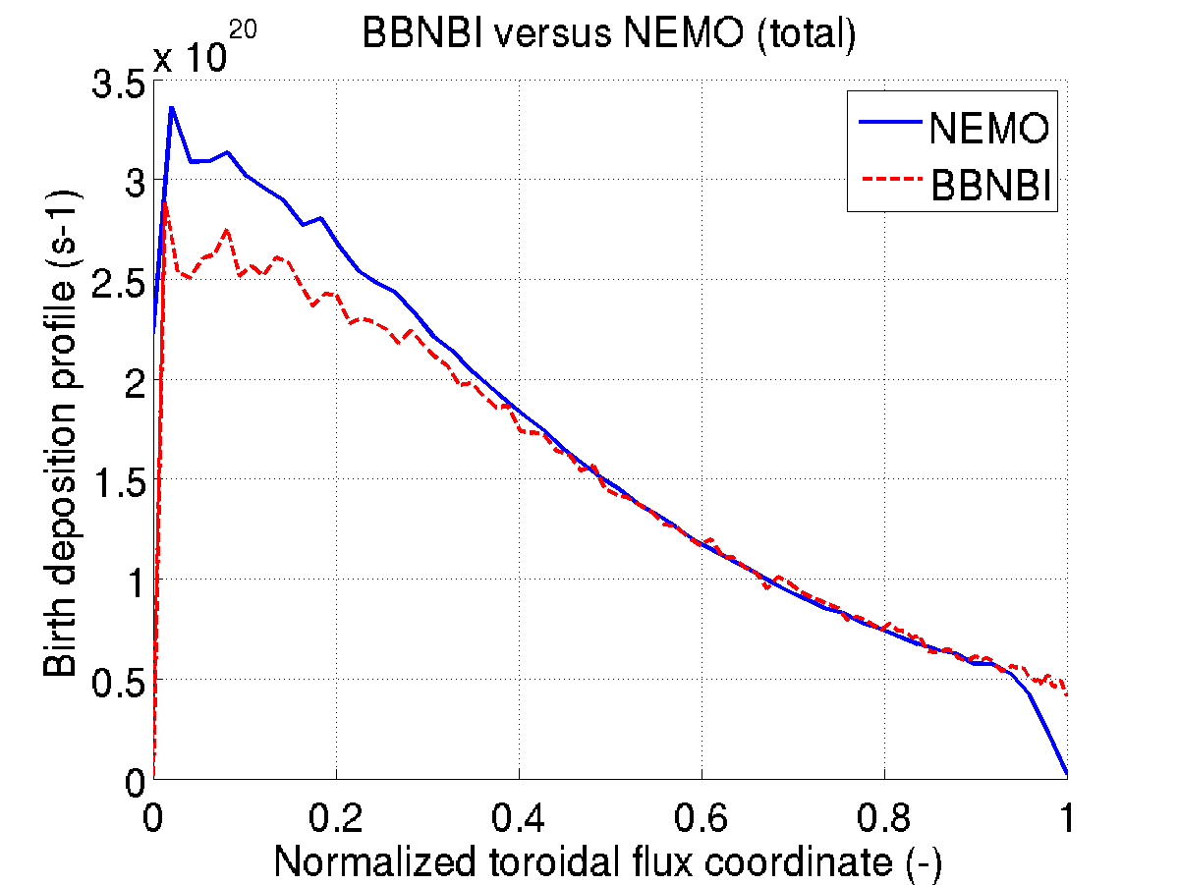
Figure 1: Birth deposition profiles using NEMO and BBNBI deposition codes for AUG.
The discrepancy between NEMO and BBNBI is still under investigation. One probable reason for this discrepancy is that the NEMO narrow beam model assumes circular shape for beamlet group units, while AUG beamlet group units are squared.
One can define different combination of codes for NBI modelling between the deposition and Fokker-Planck codes. At the time of the AUG benchmark, RISK and NBISIM were the only available Fokker-Planck calculations. For this reason, the available combinations were NEMO/RISK, BBNBI/RISK, NEMO/NBISIM and BBNBI/NBISIM. Since NBISIM does not provide the neutral beam current drive (NBCD), it is not part of the comparison for NBCD profiles. The figures below show the benchmark of the power transferred to the bulk and the NBCD for AUG:
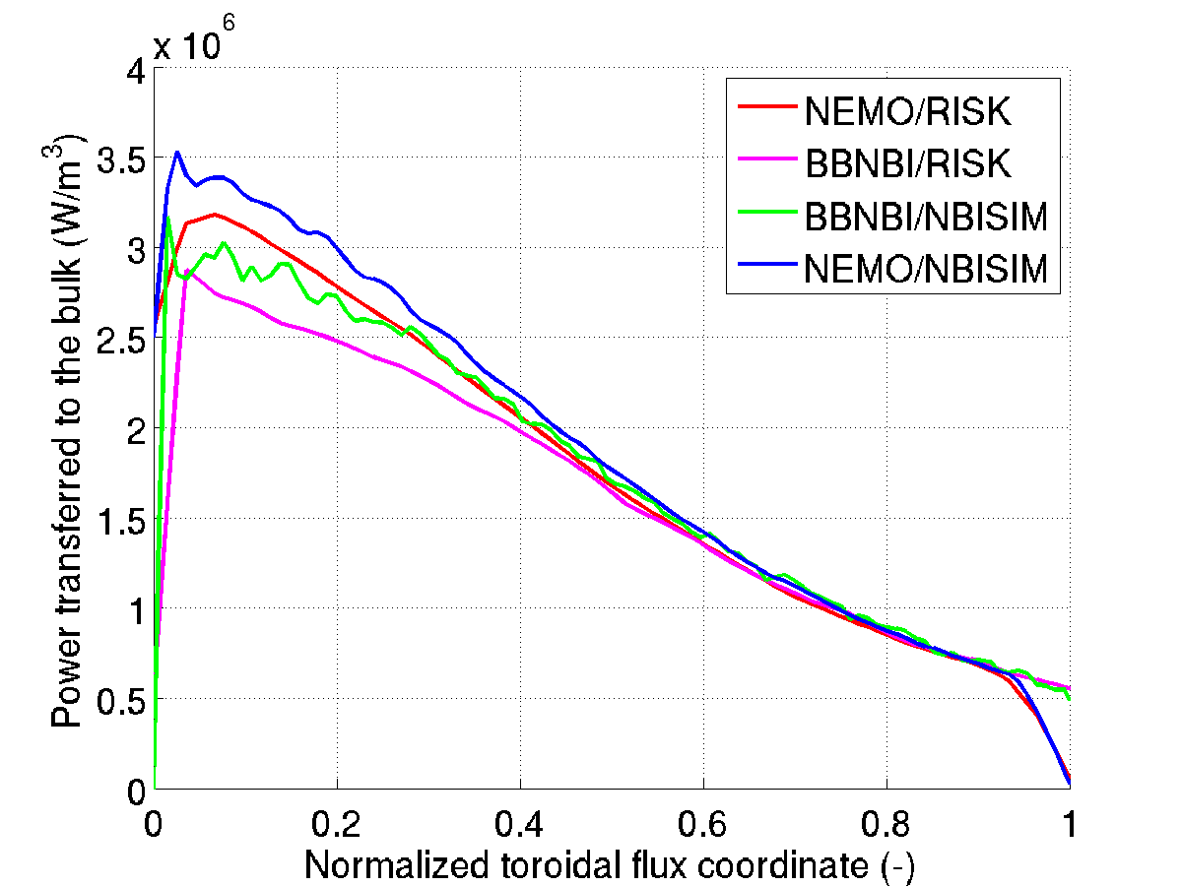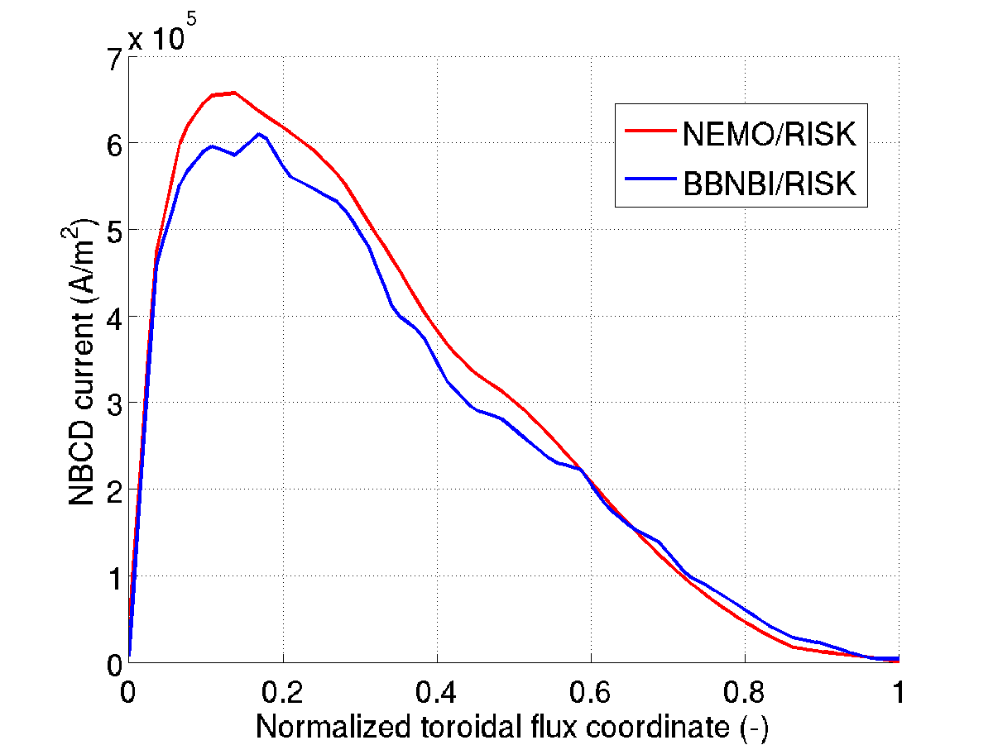
Figure 2: Left figure: profiles of power transferred to the bulk using NEMO/RISK, BBNBI/RISK, BBNBI/NBISIM and NEMO/NBISIM. Right figure: NBCD profiles using NEMO/RISK and BBNBI/RISK, for AUG.
- The discrepancy observed for the power to the bulk is due to the discrepancy between the BBNBI and NEMO deposition codes, as mentioned above. Otherwise an overall good agreement is observed between the 4 combinations.

- The comparison of the NBCD profile between the two combinations shows a good agreement.

B) JET equilibrium (userid=mires, JET #77922, run 182)
The benchmark for JET has been updated recently using the 4.10b UAL data version. For this benchmark, all deposition (x2) and Fokker-Planck codes (x4) were available; therefore 8 different combinations have been tested.
The comparison of the power transferred to the bulk (8 combinations) and the NBCD profiles (6 combinations since NBISIM does not calculate the NBCD) are shown in the figures below:

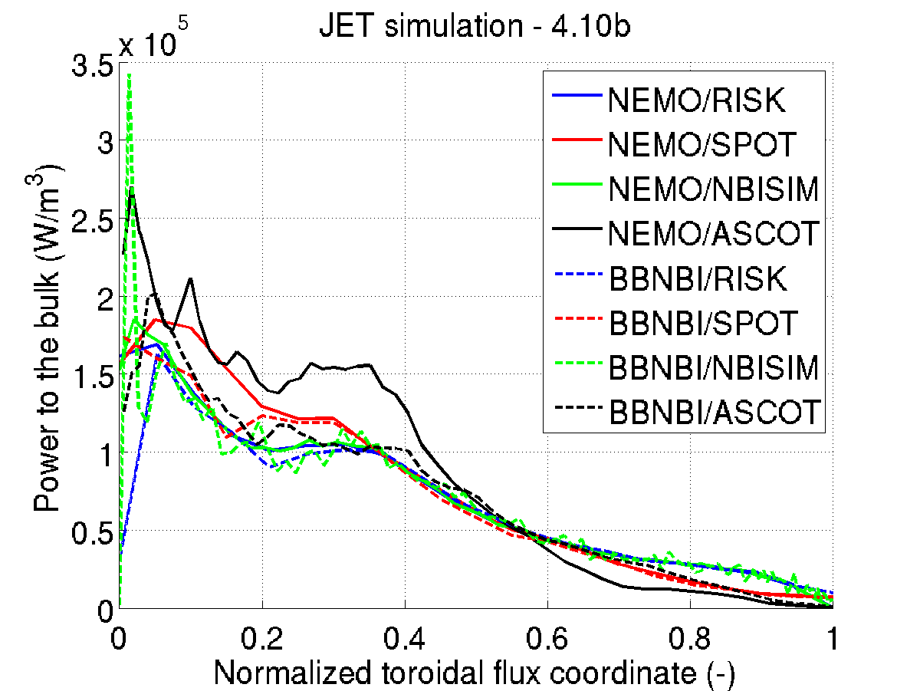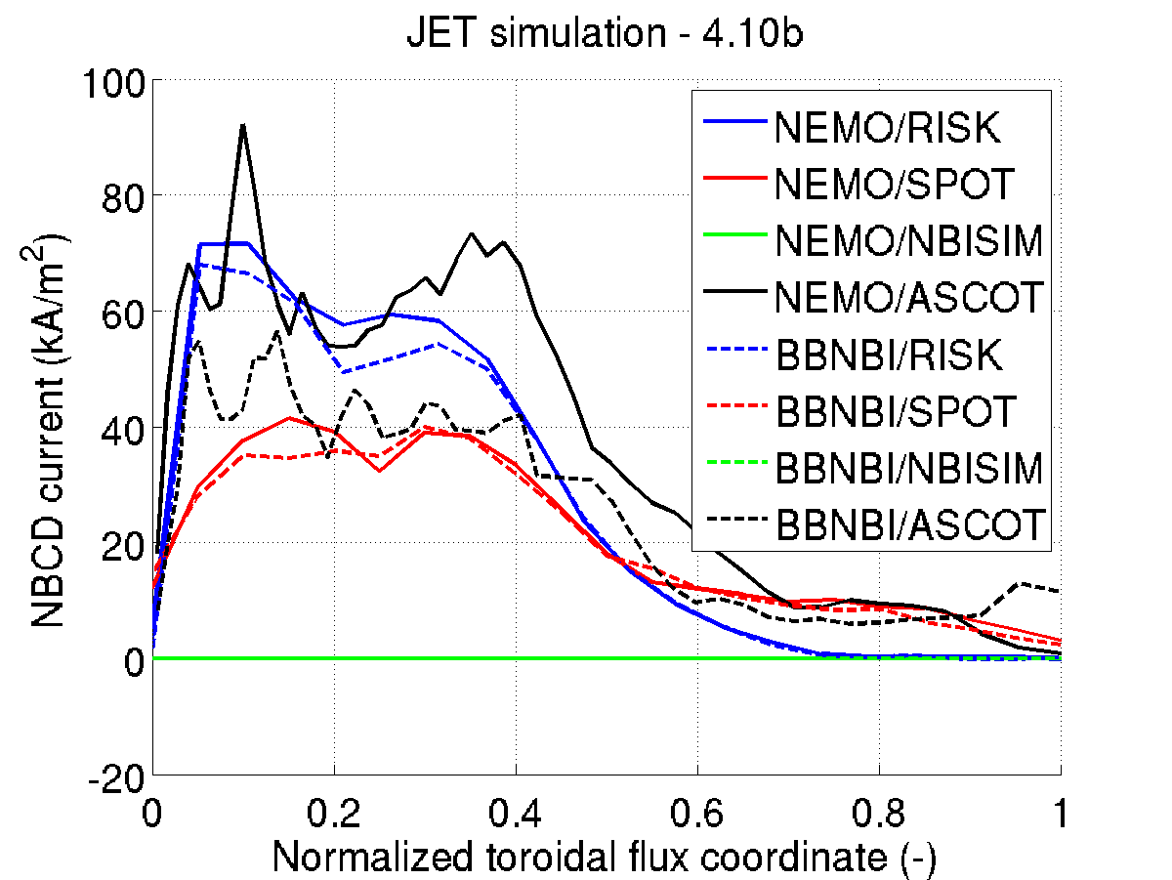
Figure 3: Left figure: profiles of power to the bulk for the 8 possible configurations.
Right figure: NBCD profiles for the 6 possible configurations, for JET.

The integrated power to the bulk and NBCD are summarized in the table below.

Combination | Power to the bulk (MW) | NBCD (MA)
NEMO/RISK | 3.77 | 1.25
NEMO/SPOT | 3.76 | 1.24
NEMO/NBISIM | 3.84 | -
NEMO/ASCOT | 3.78 | 1.90
BBNBI/RISK | 3.79 | 1.18
BBNBI/SPOT | 3.53 | 1.18
BBNBI/NBISIM | 3.85 | -
BBNBI/ASCOT | 3.52 | 1.38

Results are compatible between all configurations. Some discrepancies remain, which are probably due to:

- Too low statistics in the cases with SPOT and ASCOT
- A probable issue in the NEMO marker generation (to run with SPOT and ASCOT)
- Orbit width effects that explain the difference between NBISIM, RISK (zero-width approximation) and SPOT, ASCOT (including orbit width effects).

Finally, the time evolution of the power to the bulk has been benchmarked between the 8 possible combinations in order to test the time management in the HCD workflow and to benchmark the slowing down processes between Fokker-Planck codes. The results are shown in the next figure:

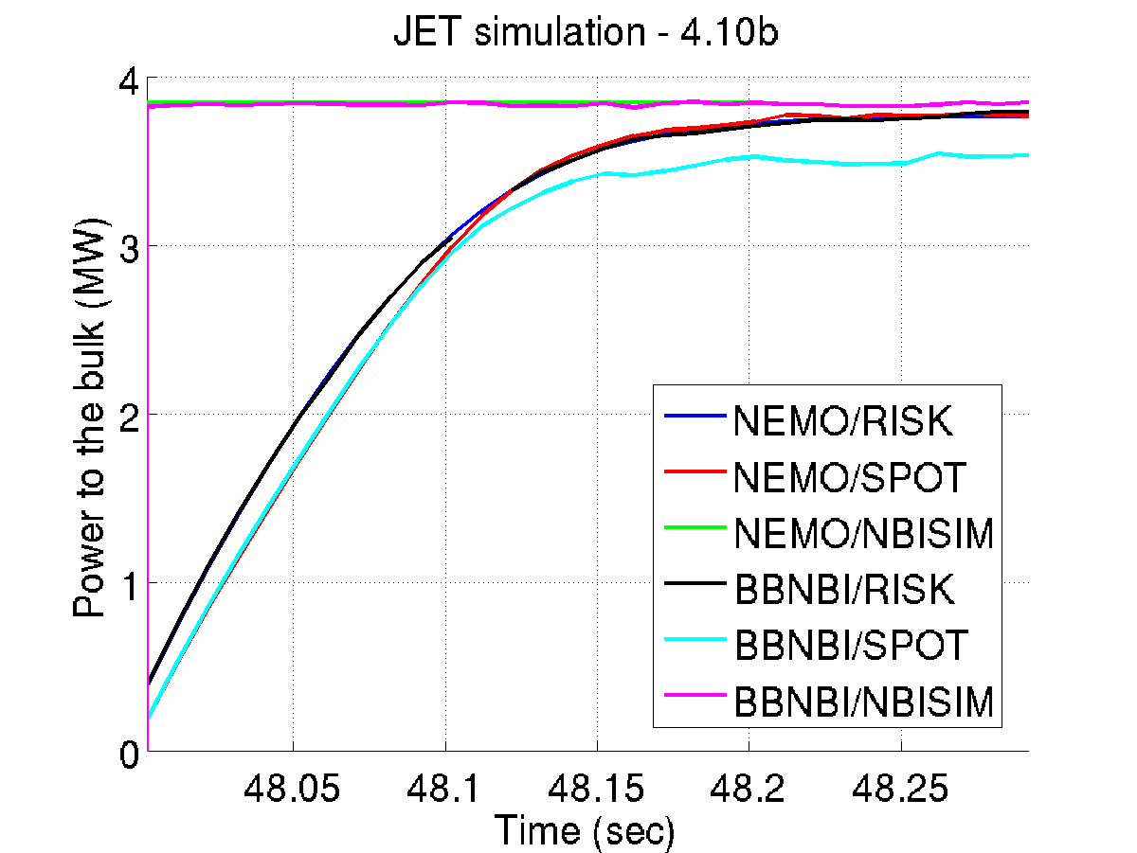

Figure 4: Time evolution of the power to the bulk for JET, between the 6 combinations; NBISIM only provides the steady-state solution of the Fokker-Planck equation; ASCOT is not shown here since the time dependence has not been implemented in ASCOT yet.

An overall good agreement is obtained for the slowing down time between the different combinations. NBISIM only provides the steady-state solution of the Fokker-Planck equation. The underestimation of the power for the combination BBNBI/SPOT has still to be understood.

Prospects:
- To update the benchmark for AUG and understand the reason for the discrepancy between NEMO and NBISIM.
- To correct the marker generation in NEMO and to repeat the JET benchmark with higher statistics for ASCOT and SPOT.
- To carry out the same NBI benchmark for ITER and DEMO1.

Datafiles where the input and results are stored:
- AUG:

They are stored in /pfs/work/mires/itmdb/itm_trees/aug/4.10a/mdsplus/0/2014_nbi_benchmarks/

Run numbers are:

INPUT | NEMO/RISK | BBNBI/RISK | NEMO/NBISIM | BBNBI/NBISIM
8 | 1067 | 1070 | 1068 | 1066

- JET:

They are stored in /pfs/work/mires/itmdb/itm_trees/jet/4.10b/mdsplus/0/2014_nbi_benchmarks/

Run numbers are:

INPUT | NEMO  /RISK | NEMO/SPOT | NEMO/NBISIM | NEMO/ASCOT | BBNBI/RISK | BBNBI/SPOT | BBNBI/NBISIM | BBNBI/ASCOT
182 | 1068 | 4068 | 3068 | 2053 | 1038 | 2038 | 3038 | 2056

Summary:
Benchmarking of NBI codes have been performed during 2014 using the WPCD infrastructures, including the use of CPOs for input and output, storing data in the UAL and code execution in Kepler workflow. As a result, all codes receive and output data on the same format, the data is accessible and traceable, and the execution environment is identical to a simulation using the ETS. The benchmark includes two types of codes; the deposition codes BBNBI and NEMO, as well as the ion-Fokker-Planck codes RISK, SPOT, ASCOT and NBISIM. The results, using ASDEX-Upgrade and JET data as input, show a fair agreement between the codes in general. The main discrepancies were observed between codes that do and do not include wide guiding centre orbits. In addition a number of other differences between the codes have been identified and corrected during this benchmark, thus improving the reliability of the codes in general.
The benchmark activity will continue in 2015, where also ITER and DEMO plasmas will be considered, along with targets tests that will clarify that e.g. sign conventions are correctly implemented.

