**Physics comparison and modelling of the JET and JT-60U core and edge: towards JT-60SA predictions**

J. Garcia1, N. Hayashi2, B. Baiocchi1, G. Giruzzi1, M. Honda2, S. Ide2, P. Maget1,E. Narita3, M. Schneider1, H. Urano2, the JT-60U Team, the JET EFDA contributors and the EU-ITM ITER Scenario Modelling Group

JET-EFDA, Culham Science Centre, Abingdon, OX14 3DB, UK

1 CEA, IRFM, 13108 Saint-Paul-lez-Durance, France

2Japan Atomic Energy Agency, Mukouyama, Naka City, Ibaraki, 311-0193 Japan

3Osaka University, Yamadaoka, Suita 565-0871, Japan

*\* See the Appendix of F. Romanelli et al., Proceedings of the 24th IAEA Fusion Energy Conference 2012, San Diego, US*

**Abstract**

An extensive exercise of physics analysis and modeling has been undertaken for the typical operational regimes of the tokamak devices JET and JT-60U with the aim of extrapolating present day experiments to JT-60SA, which share characteristics with both tokamaks. A series of representative discharges of two operationalscenarios, H-mode and hybrid have been used for this purpose.Predictive simulations of core turbulence, particle transport, current diffusion and pedestal pressure have been carried out with different combination of models. The ability of the models for reproducing the experimental data is analyzed and scenario calculations for JT-60SA are performed following an optimum simulation framework.

1. **Introduction**

In the framework of the construction of new tokamaks, such as JT-60SA, ITER and DEMO,the necessity of predicting the performance of the main operation scenarios has been identified as a main goal, both for the detailed definition of the properties of various machine subsystems (H&CD, control coils, diagnostics) and in order to establish a reliable starting point for plasma operation.

For this purpose, validation of the main models available for the plasma simulation is mandatory. These include, e.g., energy and particle transport, current, rotation and their sources, pedestal pressure and fast particles. JT-60SA [1] is a machine designed on the basis of the results of JT-60U, and using an upgrade of the JT-60U Neutral Beam Injection (NBI) system; on the other hand, it has practically the same size as JET, which also has NBI as the main H&CD system. Therefore, it appears that simulations of JT-60SA scenarios should be based at least on experimental results of the two machines that are the most similar, for size and configuration: JT-60U and JET. On this basis, an extensive validation exercise has been undertaken with the aim, as well, of expanding the knowledge of these models towards more realistic simulation of future tokamak devices such as ITER and DEMO.

For that purpose, in the framework of a broad research plan based on JT-60SA [1], a series of representative discharges of the three main operational scenarios, H-mode, hybrid and steady-state have been selected for each device. A subset of these discharges, inductive H-modesand hybrids are discussed in this paper and their main parameters can be found in table I.

The work has been divided in several stages. First, an analysis of the physics involved in the core and at the edge has been carried out with the aim of understanding the possiblesuccessor failure of the models applied. Then, predictive simulations for the temperature profiles have been carried out with three transport models, Bohm-GyroBohm [2], CDBM [3] and GLF23 [4], and by adjusting, as a first step, the pedestal, rotation and density to experimental values whenever available. To carry out this programme, the integrated modelling codes CRONOS [5] and TOPICS [6] have been used in order to benchmark the models in both codes. Finally, fully predictive simulations of temperatures, density and pedestal have been performed. In the case of the pedestal, the density at the edge is forced to follow neoclassical transport, whereas the pedestal temperature is calculated by using Cordey two-term scaling [7]. With this approach, calculations for JT-60SA have been carried out.

The paper is organizes as follows. In section 2 the core and edge physics analysis is shown for selected JET and JT-60U discharges. In section 3 the results of predictive simulations of the temperatures are compared with the experimental data. In section 4, an analysis and simulation of particle transport for both devices will be shown. In section 5, fully self-consistent simulations of current density, heat and particle transport and pedestal pressure are discussed. The statistical analysis of the performance of the models applied in this paper will be also carried out in this section.Finally, in section 6, simulations for two JT-60SA scenarios, inductive H-mode and hybrid, are shown as a conclusion of all the previous analysis.

|  |  |  |  |  |  |  |  |
| --- | --- | --- | --- | --- | --- | --- | --- |
| **Discharge** | **q95** | **κ/δ** | **Bt (T)** | **βN** | **n/nGw** | **Ip (MA)** | **Pin (MW)** |
| Inductive H-mode JT-60U #33654 | 3.0 | 1.53/0.16 | 3.1 | 1.1 | 0.48 | 1.8 | 10 |
| Inductive H-mode JT-60U #33655 | 3.0 | 1.53/0.16 | 3.1 | 1.1 | 0.48 | 1.8 | 10 |
| Hybrid JT-60U #48158 | 3.2 | 1.40/0.33 | 1.5 | 2.6 | 0.50 | 0.9 | 7.5 |
| H-mode JET #73344 | 3.5 | 1.75/0.40 | 2.7 | 1.5 | 0.75 | 2.5 | 12 |
| H-mode JET #77070 | 3.5 | 1.75/0.40 | 2.7 | 1.5 | 0.75 | 2.5 | 15 |
| Hybrid JET #75225 | 4.0 | 1.64/0.24 | 2.0 | 3.0 | 0.45 | 1.7 | 17 |
| Hybrid JET #77922 | 4.3 | 1.64/0.24 | 2.0 | 2.7 | 0.70 | 1.7 | 17 |

*TABLE I Main characteristics of JT-60U shots 33654, 33655, 48158 and JET 73344, 77070,75225 and 77922 whereκ/δ is the elongation/triangularity, Bt is the magnetic field in the axis, βN is the normalized beta, n/nGwis the ratio between the plasma densityand the Greenwald density limit, Ip is the total current and Pin the injected power*

1. **Physics analysis**

Linear gyrokinetic analysis have been performed with the GENE [8] code for the JET discharges 73344 and 75225[9] and for the JT-60U discharges 33654 and 48158 [10]. For the gyrokinetic analysis of the discharges, all simulations included kinetic electrons, collisions, and electromagnetic effects. The geometry used was calculated by HELENA [11]on the basis of the interpretative analyses of the discharges. The turbulent linear growth rates γ are in units of cs/R, with  and mi the main ion mass. In these electromagnetic simulations, both δB⊥ and δB|| fluctuations were computed as they can play a significant role in high β discharges [12].The selected time for the JET discharge 75225 is t=6.03s, in which the performance is maximized and no core MHD is detected and at t=27s for the JT-60U discharge 48158. For the inductive H-modes discharges the time is t=9.2s for JET 73344 and t=8.0s for JT-60U 33654. The region for the scan is ρ=0.33, with ρ the normalized toroidal radius, as it is a point representative of the core turbulence for hybrid scenarios in which no significant sawteeth activity is found and ρ=0.5 for the inductive ones, as the inner core region is dominated by MHD activity. Only thermal species have been taken into account in these simulations.

As shown in in figure 1, for the inductive H-mode discharges, the turbulence is dominated by the Ion Temperature Gradient (ITG) instability [13], as expected from this low beta discharges. On the other hand, for the hybrid discharges, some differences are found. For the JET 75225 discharge, as shown in figure 2, ITG dominates for the full spectrum. However, the spectrum for the JT-60U 48158 discharge is dominated by the Trapped Electron Mode (TEM)regime for ky>0.3, likely due to the high normalized density gradient,, much higher than in the JET case, *,* and which are known to drive this type of instability [14].The different turbulence regime can have an impact on the results of predictive heat transport simulations as transport models have usually difficulties for reproducing temperatures in such regimes [15]. This point will be further analyzed in following sections.

The peeling-ballooning stability analysis of the hybrid discharges JET 75225 and JT-60U 48158 have been also carried out in order to validate whether the assumptions for the pressure pedestal assumed in section 6 for the JT-60SA tokamak, based on JET and JT-60U data, can be verified using this theory. For that purpose the code MISHKA [16] and the procedure described in [17] are used. In figure 3 the stability boundary and the pressure pedestal are shown. For both discharges, the experimental pressure lies at the ballooning region of the stable part of the diagram. A pedestal pressure close to the boundary or inside the stable region will be considered as a correct estimate for JT-60SA.

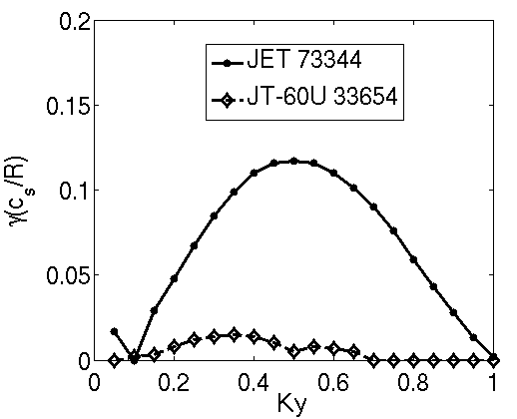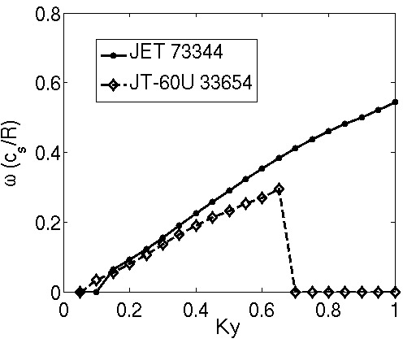

*Figure 1*Linear growth rates (left) and frequencies (right) for discharges JET 73344 and JT-60U 33654

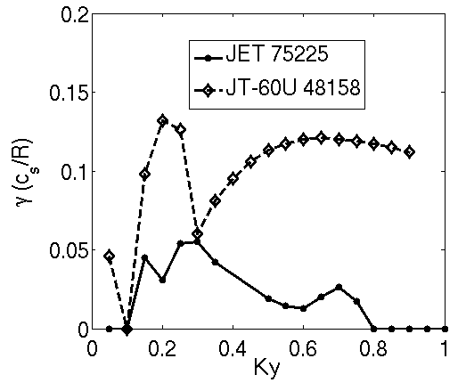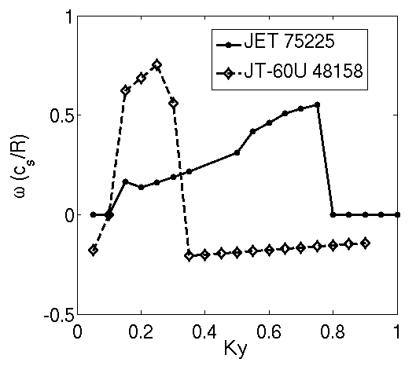

*Figure 2*Linear growth rates (left) and frequencies (right) for discharges JET 75225 and JT-60U 48158

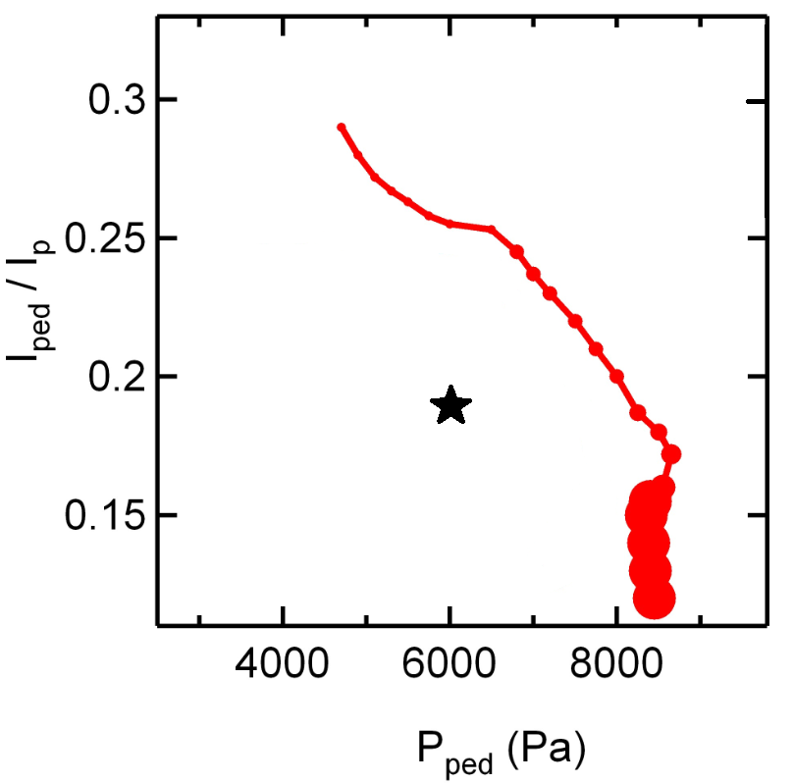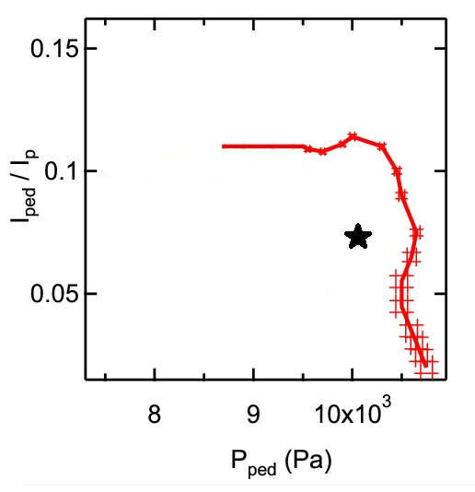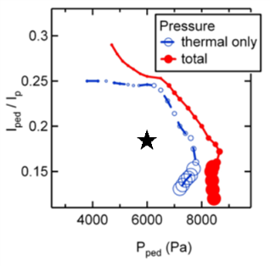

*Figure 3 Peeling-Ballooning analysis of the discharges JT-60U 48158 (left) and JET 75225 (right). The experimental value is marked with a black star.*

1. **Heat transport predictive simulation**

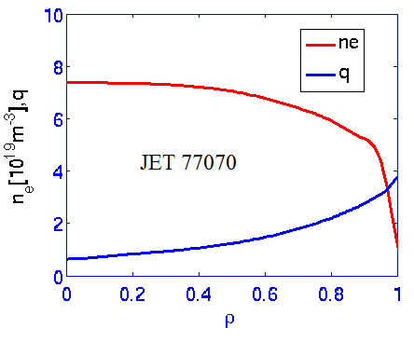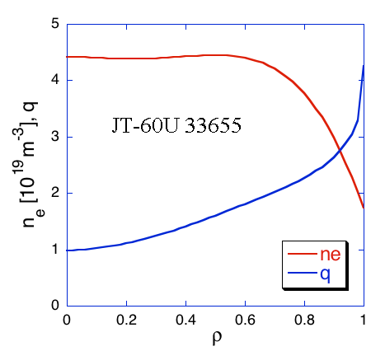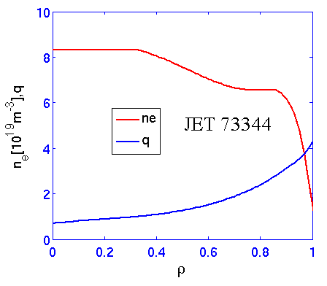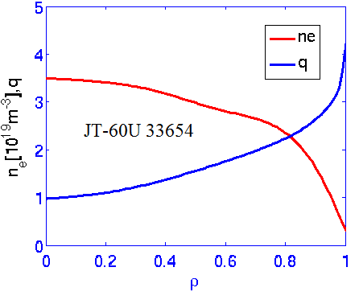

*Figure 4 Density and q profiles used for JT-60U shots 33655 (a) 33654 (b) and JET shots 73344 (c) and 77070 (d)*

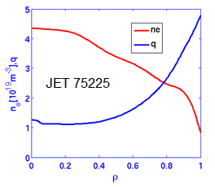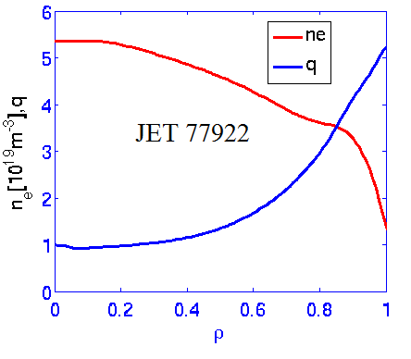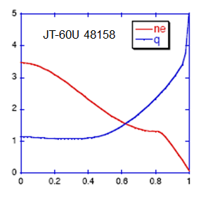

*Figure 5 Density and q profiles used for JT-60U shot 48158 (left) and JET shots 75225 (center) and 77922 (right)*

Predictive simulations of the temperature profiles have been carried out with the transport models Bohm-GyroBohm, CDBM and GLF23with the codes CRONOS and Topics. The NBI current drive and fast ion pressure has been calculated with the MonteCarlo codes NEMO/SPOT [18] for JET discharges and F3D-OMFC [19] for the JT-60U discharges. In these simulations, the pedestal temperature and density have been been fixed to experimental values.

Regarding the CDBM transport model, a modification has been implemented in order to take into account the relatively high fast ion population in some of the discharges, mainly hybrid ones. For that purpose, the fast ion pressure is included in the normalized pressure gradient , with R major radius, r minor radius, q safety factor, with <P> the volume averaged pressure and B the magnetic field which is taken into account in the function

 (1)

where s is the magnetic shear. The thermal pressure gradient , only including the thermal pressure, is used in the other terms.The original heat diffusivities [3] are mended as follows:and G()=(21/2/(2+1))3/2with κ the elongation,the electron plasma frequency and *νA* is the toroidal Alfvén velocity.

The q and density profilesfor each of the discharges at the time considered are shown in figure 4and figure 5for the inductive H-modes and hybrids respectively. For the ExB shearing rate γExB, the recommended multiplier αExB=1.35 has been used throughout this study when GLF23 transport model has been applied. The experimental measured rotation has been always taken as a boundary condition.

The predictive results for the inductive scenarios are shown in figures 6 and 7. In general, the agreement between both codes and with experimental data for the inductive H-modes is acceptable, in particular for the GLF23 transport model. Except for the electron temperature of the JT-60U discharge 33654, which is lower than the experimental data, GLF23 gives reasonable results for the other temperature profiles. On the other hand, CDBM transport model is quite close to GLF23 results although it tends to give somewhat lower temperatures. This is particularly clear for the JET discharges. Finally, Bohm-GyroBohm model is accurate for the JET discharges but with more scattered results for the JT-60U ones. Therefore, none of the models give equally accurate results for all the discharges analyzed, but the predictions remain within reasonable agreement. It is important to stress that no sawtooth model has been used for the simulation of these discharges and thus the predictions in the central region, which is likely to be affected by MHD, must be taken with care.

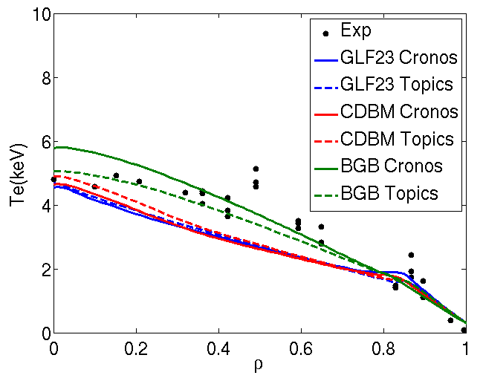

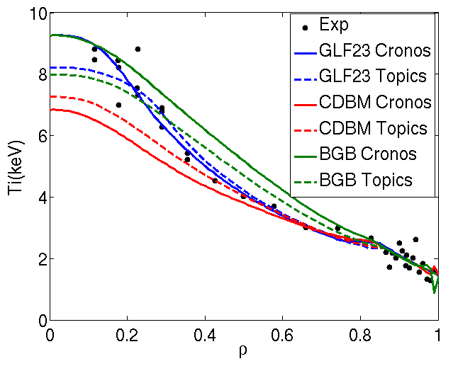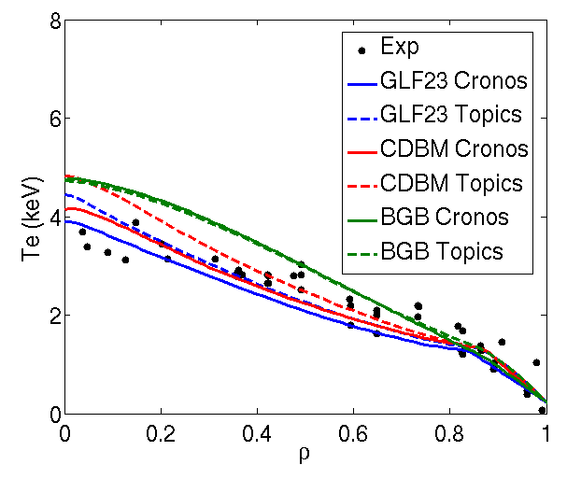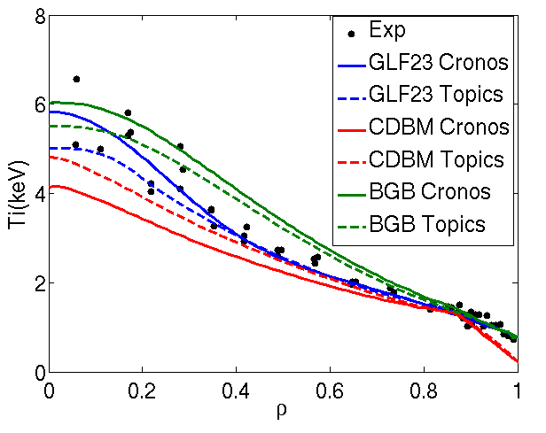

*Figure 6Comparison between the electron and ion temperatures profiles with those obtained with CRONOS and TOPICS with GLF23, CDBM and Bohm-GyroBohm transport models for the shots 33655 (a,b) and 33654 (c,d) from JT-60U.*

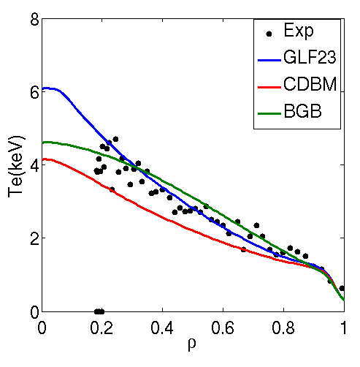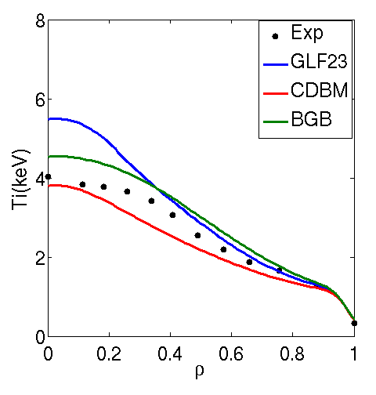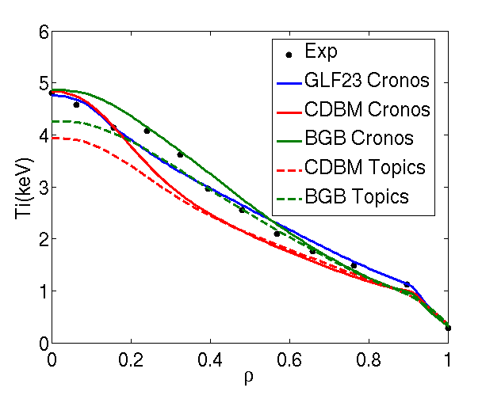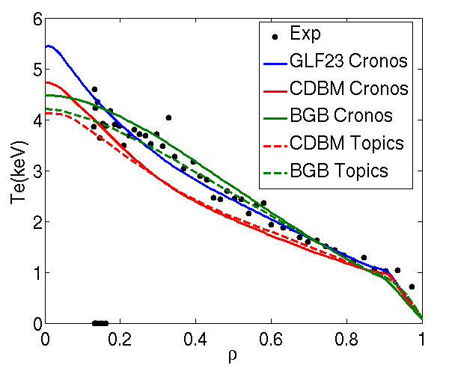

*Figure 7 Comparison between the electron and ion temperatures profiles with those obtained with CRONOS and TOPICS with GLF23, CDBM and Bohm-GyroBohm transport models for the shots 73344 (a,b) and 77070 (c,d) from JET.*

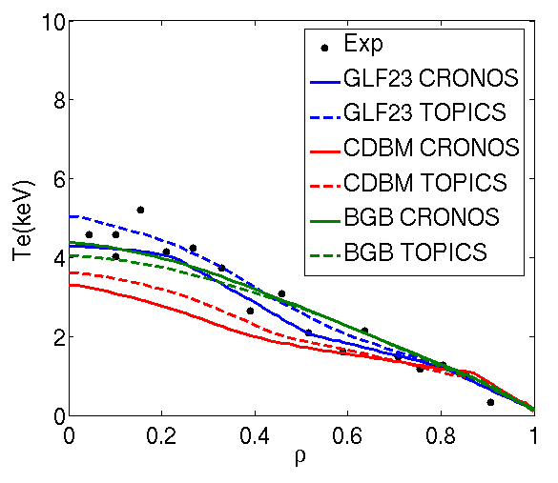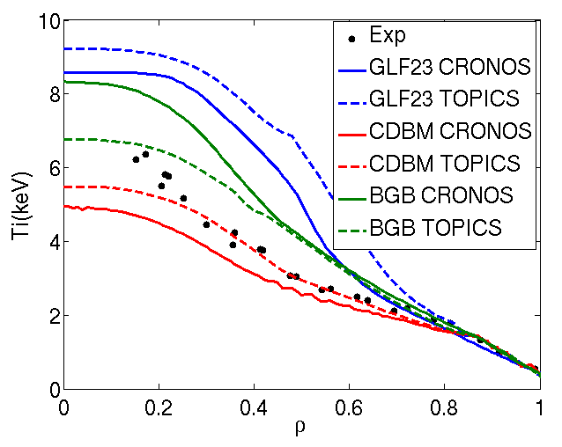

*Figure 8Comparison between the electron and ion temperatures profiles with those obtained with CRONOS and TOPICS with GLF23, CDBM and Bohm-GyroBohm transport models for the JT-60U shot 48158.*

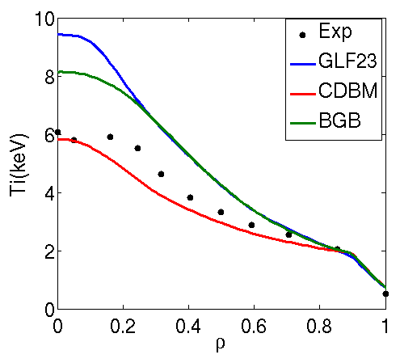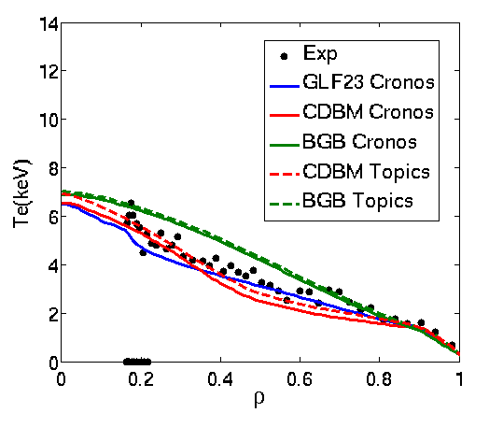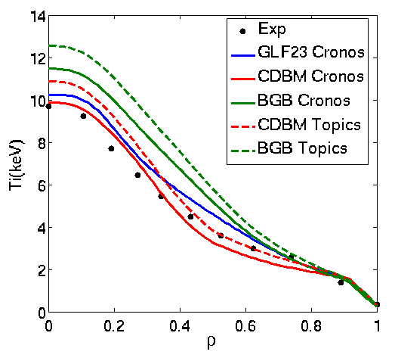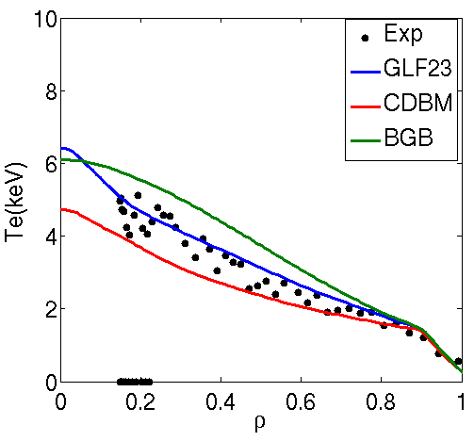

*Figure 9Comparison between the electron and ion temperatures profiles with those obtained with CRONOS and TOPICS with GLF23, CDBM and Bohm-GyroBohm transport models for the shots 75225(a,b) and 77922 (c,d) from JET.*

Predictive simulations of hybrid discharges have been also carried out. In figure 8 the simulation of the JT-60U discharge 48158 is shown whereas the JET discharges are shown in figure 9. In this case, Bohm-GyroBohm transport model tends to overestimate temperatures, even for JET, and mainly for ions. On the other hand, CDBM gives results closer to experimental data, mainly for the ions. Finally, as expected from other analyses of the same kind [20], the GLF23 transport model tends to overestimate the ion temperature whereas it gives correct results for the electron temperature. The reason for this is likely the too strong impact of rotation on these discharges through the ExB shearing rate. In order to explore this possibility, the same simulations have been carried out with CRONOS by setting αExB=0. The ion temperatures, shown in figure 10, clearly drop and get close to experimental ones in the case of JET. However, for the JT-60U discharge, a region of flat temperature appears in 0.2<ρ <0.5 which makes this new calculation much lower than reality. This behavior can be explained by the existence of TEM modes in that region, as pointed out in section2, for which GLF23 overestimates heat transport. A more suited transport model for that regime would be TGLF, which has been specially created for dealing with these modes [21].

In conclusion, whereas for inductive H-modes, the models considered do not largely deviate from experimental data, mainly with GLF23, the situation for hybrids tends to be more scattered, with a clear overestimation of ion temperatures because of the too strong impact of rotation on GLF23, which makes the prediction by CDBM more suitable. This has important implications for the extrapolation to JT-60SA, as will be shown in the following sections.

The overall statistical analysis of the predictive simulations will be shown in section 5.

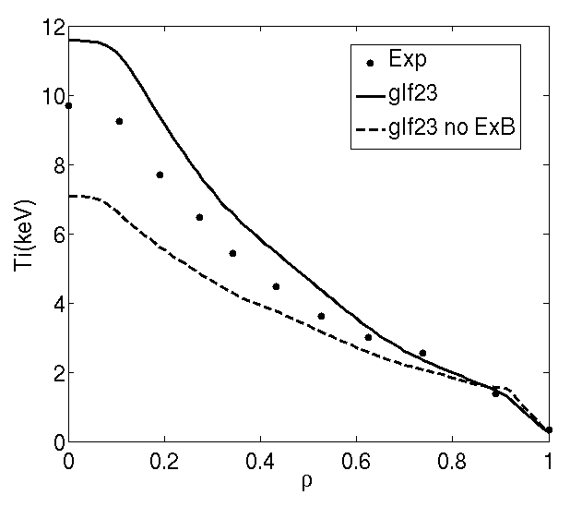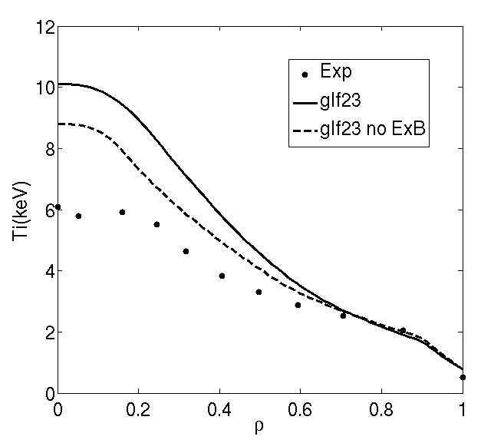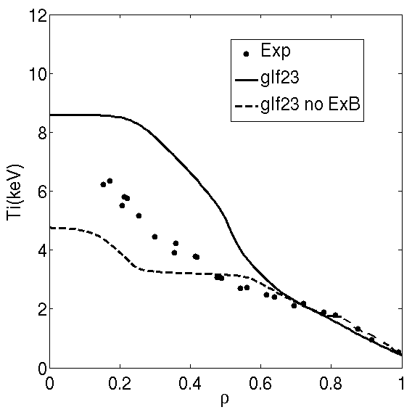

*Figure 10Comparison between the electron and ion temperatures profiles obtained with GLF23 transport model with and without the ExB shearing rate factor for the JET shots 75225 (left) 77922 (center) and JT-60U shot 48158 (right)*

1. **Particle transport analysis**

Particle transport has been also analysed by performing simultaneous predictions of ion and electron temperature profiles and electron density. Since it has been shownin the previous section that GLF23 transport model is able to properly reproduce inductive H-mode scenarios, it has been used both for heat and particle transport for this kind of scenarios. For the advanced regimes, CDBM transport model has been also considered for heat transport whereas GLF23 has been always used for particle transport.

The density at the separatrix and at the top of the pedestal has been fixed to experimental values. In order to do this, the GLF23 transport model has been applied from the center up to the pedestal foot and outside that point, the transport has been adjusted by assuming that the particle diffusivity is proportional to the ion neoclassical heat transport, i.e. , where C is a constant to be adjusted. The sources considered in these simulations are the ones obtained from NBI. The sensitivity of the results to these sources will be analyzed.

In figure 11 and 12,the CRONOS simulation of the JET discharge 73344and JT-60U discharge 33654 are shown. The density profile is reasonably well simulated whereas the temperatures do not differ from the ones obtained from the fixed density simulations. In particular, the low density peaking characteristic of the inductive regimes is recovered by this model, although the density profile for the discharge JT-60U 33654 is slightly overestimated.

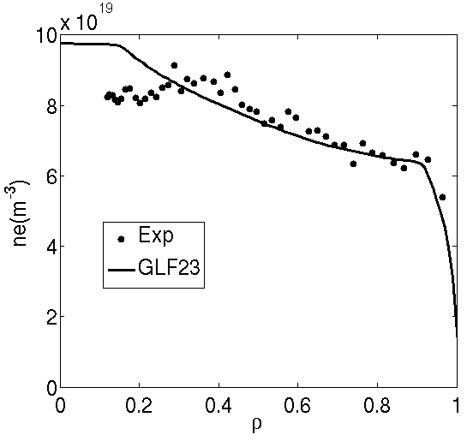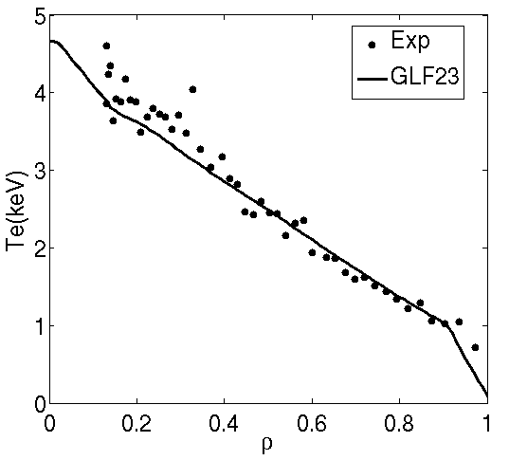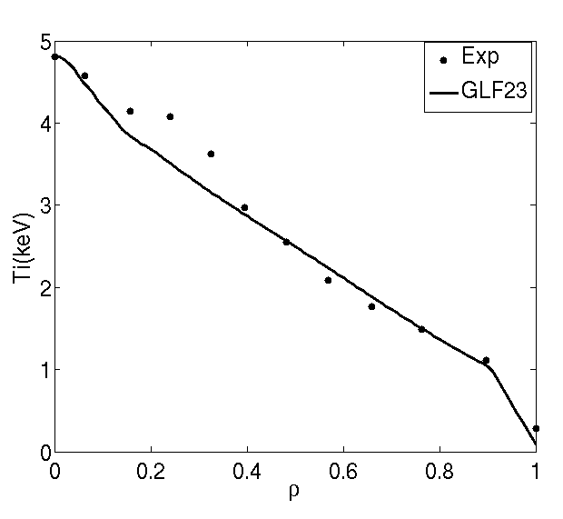

*Figure 11Comparison between the electron and ion temperature and electron density profiles with the ones obtained by using GLF23 for simulating particle and heat transport for the JET shot 73344*

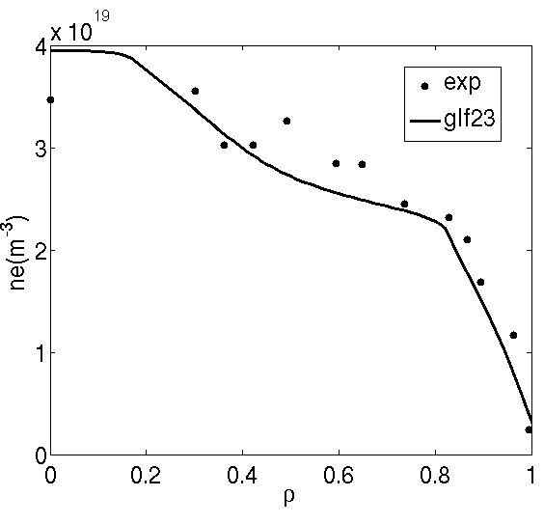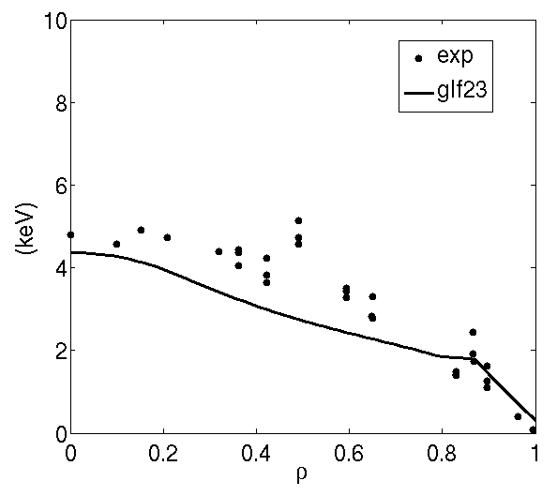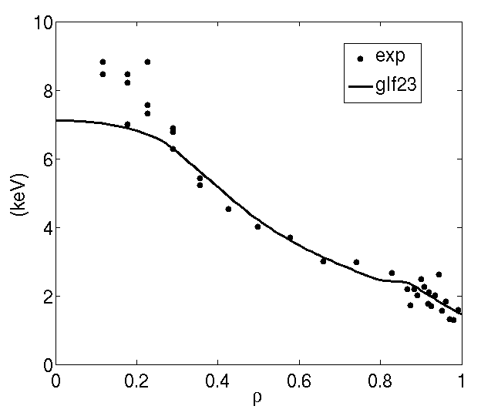

*Figure 12Comparison between the electron and ion temperature and electron density profiles with the ones obtained by using GLF23 for simulating particle and heat transport for the JT-60U shot 33654*

The hybrid shots, 75225 from JET and 48158 from JT-60U have been simulated with both GLF23or CDBM for the heat transport and GLF23 for particle transport. The higher peaking obtained in these scenarios is generally well reproduced by the simulations as shown in figure 13 and 14. In the case of 75225, the simulation with GLF23 slightly overestimates the peaking, in agreement with previous analyses [22], whereas simulation with GLF23and CDBM slightly underestimates it. Regarding the temperatures, they are close to the ones obtained with fixed density profile. In the case of the JT-60U shot 48158, the trend is the opposite, which can be explained by the overestimated ion temperature profile, whereas when the simulation is performed with GLF23+CDBM the density tends to be closer to experimental data. In any case, both simulations cover the experimental data and give a margin of confidence for future extrapolations.

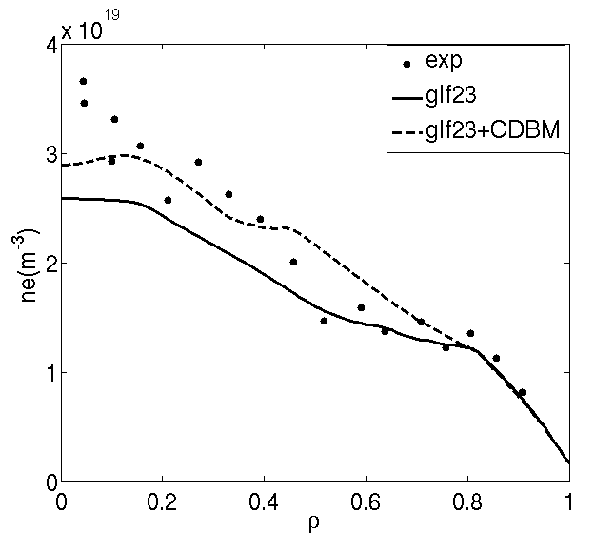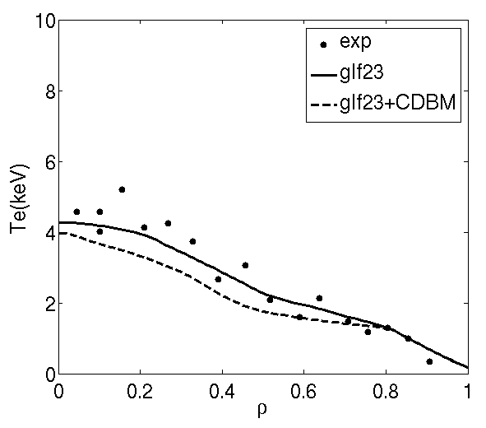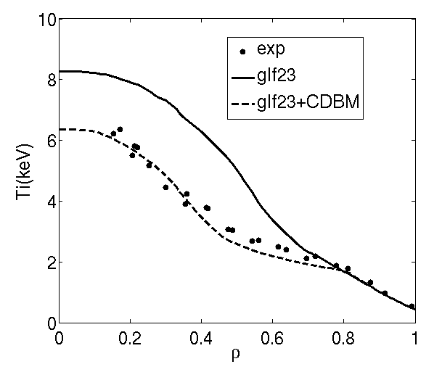

*Figure 13Comparison between the electron and ion temperature and electron density profiles with the ones obtained by using GLF23 and CDBM (only for heat transport) for simulating particle and heat transport for the JT-60U shot 48158*

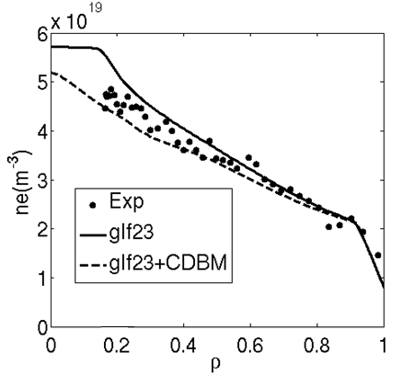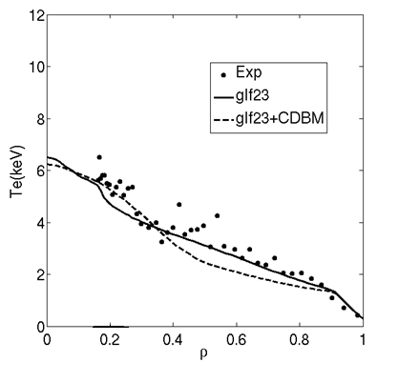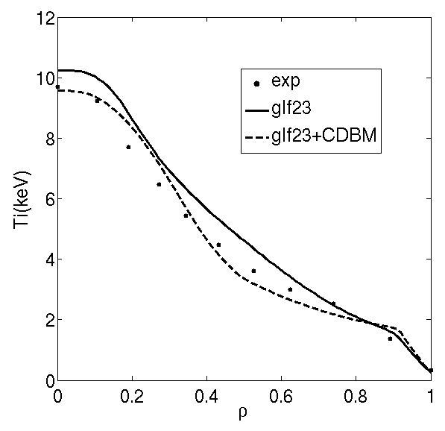

*Figure 14Comparison between the electron and ion temperature and electron density profiles with the ones obtained by using GLF23 and CDBM (only for heat transport) for simulating particle and heat transport for the JET shot 75225*

The fact that the simulations are able to reproduce the transition from low density peaking for inductive H-modes to high density peaking for hybrid scenarios is of particular interest for the extrapolation to JT-60SA, a device particularly focused on advanced scenarios. The density peaking generates more bootstrap current, something essential for the self-sustainment of advanced regimes in future devices as JT-60SA and ITER [23]. In order to analyse the reasons for the extra peaking in advanced regimes, two alternative simulations have been done for both JET discharge 75225 and JT-60U 48158 by removing the particle source from the NBI and setting αExB=0 in the simulations with GLF23. In figure 15, results show as both, ExB flow shear and particle source have a similar impact on the density peaking which is reduced from to for the JET shot 75225 and  to for the JT-60U shot 48158 when both effects are not taken into account simultaneously. However, the strong effect of the ExB flow shear on the density has to be carefully analyzed since, as previously shown, this effect is overestimated by this transport model. The impact on JT-60SA scenarios will be analyzed in the following sections.

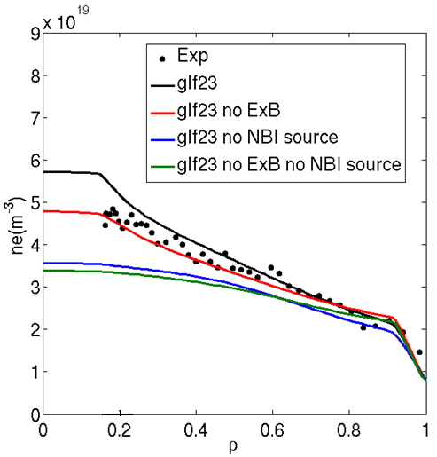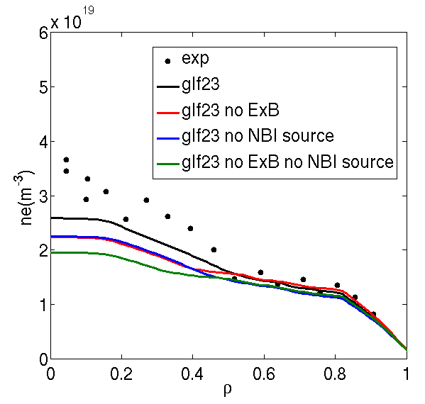

*Figure 15 Impact of ExB shearing rate and NBI particle source on density profiles for the JET shot 75225 (left) and JT-60U shot 48158 (right)*

1. **Pedestal predictions**

With the aim of analysing whetherthe pedestal pressurecan be extrapolated for JT-60SA from the discharges selected in this study, self-consistent simulations of particle transport, heat transport and pedestal temperature have been performed for the discharges 33654 and 48158 from JT-60U and 73344 and 75225 from JET. In order to calculate the pedestal temperature, the following scaling from [7] is used

 (2)

where I is the current (MA), R major radius (m), P thermal loss power (MW), n density (10−19 m−3), B toroidal field (T), κa elongation, ε aspect ratio, m atomic mass and Fq (≡q95/qcyl with qcyl defined as 5κaa2B/RI with a minor radius). The position of the top of pedestal is fixed to the experimental value.

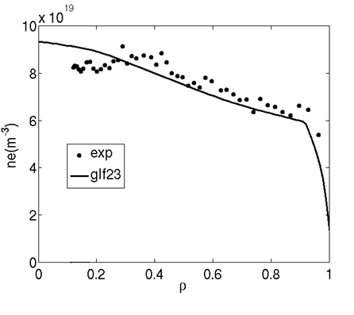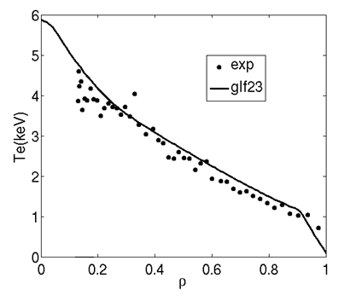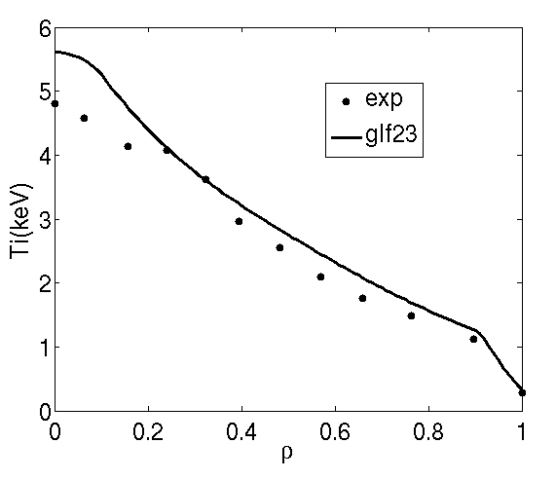

*Figure 16Comparison between the electron and ion temperature and electron density profiles with the ones obtained by using GLF23 for simulating particle and heat transport and scaling from (2) for the pedestal pressure for the JET shot 73344*

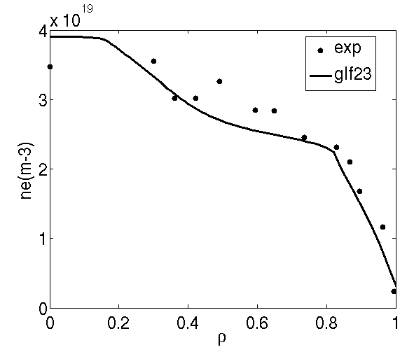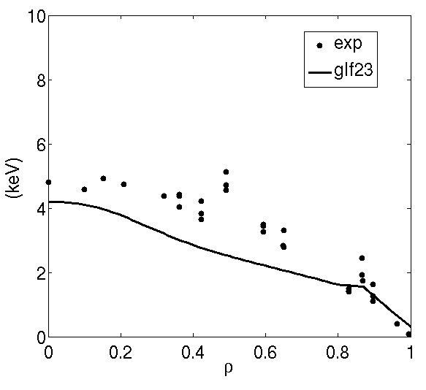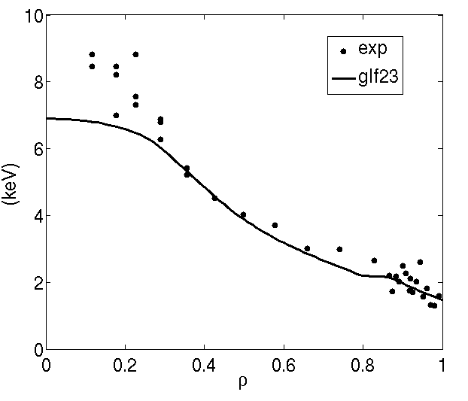

*Figure 17Comparison between the electron and ion temperature and electron density profiles with the ones obtained by using GLF23 for simulating particle and heat transport and scaling from (2) for the pedestal pressure for the JT-60U shot 33654*

In figures 16 and 17 the electron density and temperature profiles obtained by CRONOS are compared with experimental data for the JT-60U discharge 33654 and JET discharge 73344. The temperature at the top of the pedestal is slightly overestimated for JET discharge 73344, which leads to a pressure of 20kPa, higher than the experimental one, 15kPa. For the JT-60U discharge 33654, the predicted pressure, 13kPa, is closer to the experimental one. The profiles obtained from these simulations are similar to the ones obtained with fixed pedestal pressure; however, due to the stiff behaviour of the GLF23 transport model, the overestimation or underestimation of the pedestal leads to differences on average temperatures that follow the same trend, as shown in table 2.

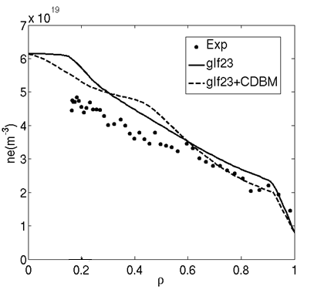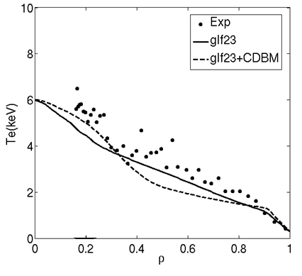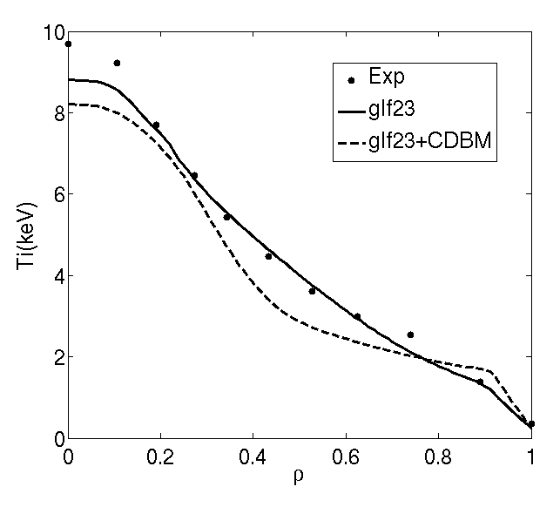

*Figure 18 Comparison between the electron and ion temperature and electron density profiles with the ones obtained by using GLF23 and CDBM (only for heat transport)and scaling from (2) for the pedestal pressure for the JET shot 75225*

Simulations for the JET discharge 75225 and JT-60U 48158 are shown in figure 18 and 19. The pedestal pressure depends on the model applied for simulating the core turbulence. When using GLF23 for temperatures and density, the pedestal pressure obtained for the JET discharge 75225, 8.2kPa is below the experimental one 10kPa. However, when the model CDBM is applied for the temperatures the pedestal is matched. This different pedestal pressure does not lead to the same trend on the core profiles because the different stiff behaviour of the models, as shown in figure 18. In spite of the fact that the ion temperature pedestal is higher for the CDBM model, the core ion temperature is lower, due to the limited stiff behaviour of this model.

The pedestal pressure for the JT-60U discharge 48158 is better predicted, 5kPa for the simulation with GLF23 and 5.4kPa with CDBM, compared to 6kPa from the experiment. The profiles obtained by means of these predictions are similar to the ones obtained from fixed pedestal simulations.

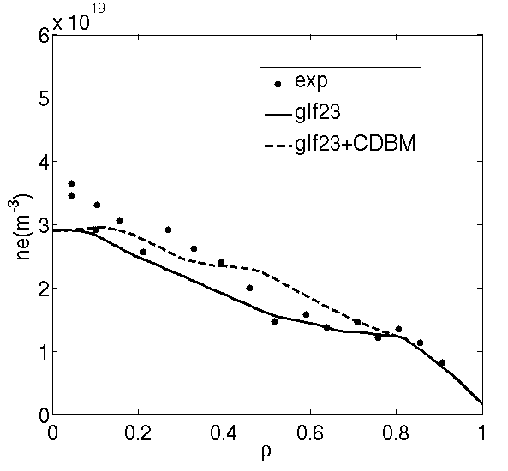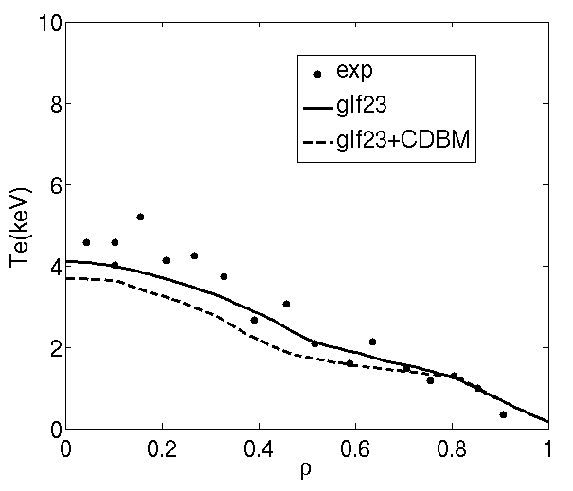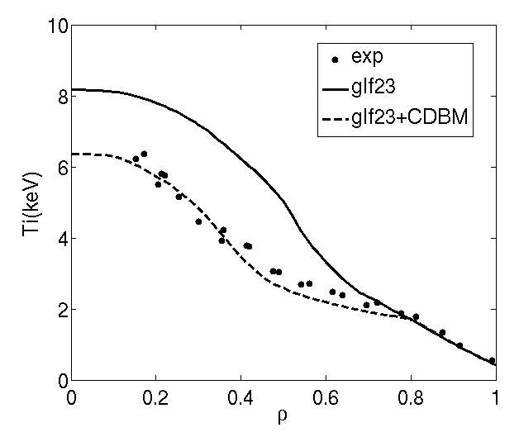

*Figure 19Comparison between the electron and ion temperature and electron density profiles with the ones obtained by using GLF23 and CDBM (only for heat transport)and scaling from (2) for the pedestal pressure for simulating particle and heat transport for the JT-60U shot 48158*

|  |  |  |  |  |  |  |  |
| --- | --- | --- | --- | --- | --- | --- | --- |
| **Discharge** | **βN** | **H98(y,2)** | **n/nGw** | **<ne>**1019 m-3 | **<Te>keV** | **<Ti>keV** | **Pped(kPa)** |
| Inductive H-mode 33654 | 1.1/1.3 | 0.65/0.85 | 0.42/0.48 | 2.3/2.4 | 2.0/2.7 | 3.2/3.4 | 13/15 |
| Inductive H-mode 73344 | 1.7/1.5 | 0.97/0.85 | 0.80/0.75 | 6.75/6.65 | 2.0/1.8 | 2.2/1.9 | 20/15 |
| Hybrid 75225 (GLF23) | 3.0/2.95 | 1.3/1.25 | 0.65/0.56 | 3.4/2.9 | 2.8/2.7 | 3.1/3.2 | 8.2/10 |
| Hybrid 75225 (GLF23+CDBM) | 2.6/2.95 | 1.15/1.25 | 0.57/0.56 | 2.8/2.9 | 2.2/2.7 | 3.2/3.2 | 10/10 |
| Hybrid 48158 (GLF23) | 2.0/2.6 | 1.05/1.07 | 0.35/0.50 | 1.40/1.55 | 1.8/2.0 | 3.4/2.5 | 5.0/6.0 |
| Hybrid 48158 (GLF23+CDBM) | 2.1/2.6 | 0.98/1.07 | 0.40/0.50 | 1.64/1.55 | 1.5/2.0 | 2.4/2.5 | 5.4/6.0 |
| **rms** | **15.6%** | **12.2%** | **17.1%** | **8.7%** | **17.6%** | **16.3%** | **18.2%** |

*TABLE II Comparison between the simulations performed in this section (left at each column) and the values obtained from experimental profiles (right at each column). The rms for each variable is shown in the last row*

In order to quantify the accuracy of the simulations and models applied, a statistical analysis has been carried out. For that purpose the standard expression for the root-mean-square (rms) deviation

(3)

has been used, where is the value obtained from experimental profiles and  the simulated one for each of the predictions performed in this section, whereas N is the total number of simulations. The general variables selected for the comparison and the rms obtained for each one are shown in table II.

The calculation shows that the results are close to experimental data. The maximum rms obtained is below 20% and it corresponds to the pedestal pressure, 18.2%. Interestingly, the rms obtained for the other variables, which depend on core profiles but also on the pedestal features, are lower. One reason is the counteracting effects between core models and edge models. One clear example is the simulation of the ion temperature of the discharge 75225 by means of the transport model GLF23. As shown in section 2, this model overestimated the ion temperature when including experimental rotation, however, as the pedestal is underestimated for this discharge, the average ion temperature, <Ti>=3.1keV is quite close to the experimental one, <Ti>=3.2keV.

1. **JT-60SA Predictions**

Predictions for different JT-60SA scenarios have been carried out with CRONOS following the general results presented in the previous sections. For that purpose, simulations including plasma current, heat and particle transport and pedestal have been performed. The general boundary conditions have been obtained from previous 0-D simulations [1]. In the case of inductive H-mode, the transport model GLF23 has been used for simulating both density and temperatures. In the case of hybrid scenario, GLF23 has been used for particle transport, and two simulations, one with GLF23 and another one with CDBM have been considered for heat transport. Since the impact of rotation is overestimated, no source of torque has been taken into account, i.e. no rotation is considered.

The density at the top of the pedestal has been simulated by reducing anomalous transport to ion heat neoclassical transport in the same way as done in section 2,. The constant C=2 has been chosen as an average of the ones used in section 3 for simulating the density profile in the different scenarios. Since the particle source at the edge is not taken into account in these simulations, the sensitivity to the different possible average densities has been taken into account by changing the constant C and keeping the density at the edge constant at 1.0x1019 m-3. An analysis of the interplay between particle source from edge neutrals and the scenarios analysed here will be performed in the future.

The temperature at the top of the pedestal is calculated by using the expression (2) whereas the width has been adjusted to follow the scaling [], where  is the normalized poloidal flux and is the poloidal beta, , with  the poloidal magnetic field, calculated at the top of the pedestal.

The heating sources are simulated by using NEMO/SPOT (including for particle source) for the NBI and REMA [24] for the Electron Cyclotron Resonant Heating and Current Drive (ECRH/ECCD). The possible sawteeth are simulated by including a continuous sawteeth model which takes into account the increase of heat and particle diffusivities when q<1.

The general results obtained for the inductive H-mode and the hybrid scenarios are shown in table III. The Greenwald fraction, fGr for the inductive scenario is fGr=0.6 and an alternative scenario with higher density, which leads to fGr=0.8, is also considered. In figure 20, the density, temperature and pressure profiles are shown for this scenario. The two densities at the top of the pedestal are ne,ped=5.5x1019 m-3 and ne,ped=7.0x1019 m-3 which are in the range of the inductive discharges from JET 73344 and 77070 analysed in section 2. A wide region of sawteeth, 0<ρ<0.45 is found, which flattens the density and temperature profiles in that region. The temperatures at the top of the pedestal are Tped=4.2keV for the low density and Tped=2.5keV for the high density. The pressure at the top of the pedestal is higher for the low density case, Pped~70kPa compared to the high density one, Pped~60kPa. This feature leads to an overall better performance for the lower density case with a total stored thermal energy Wth=26MJ and β ~3.6, with respect to the high density case: Wth=23.5MJ and β~3.2. The width of the pedestal is found to be ρ≈0.94 in both simulations.



*Figure 20JT-60SA inductive H-mode simulation densities (a) Electron and ion temperatures (b) Electron pressure (c) and ion pressure (d) obtained with GLF23 transport model*

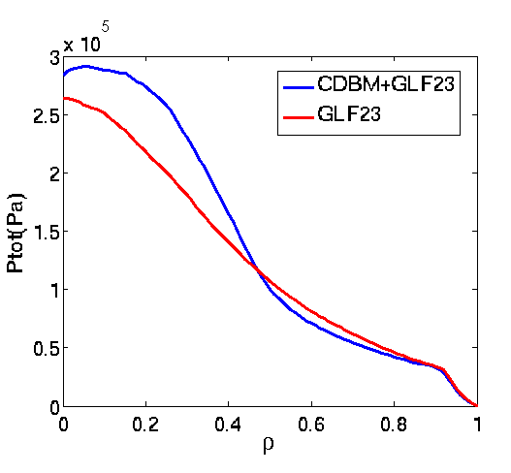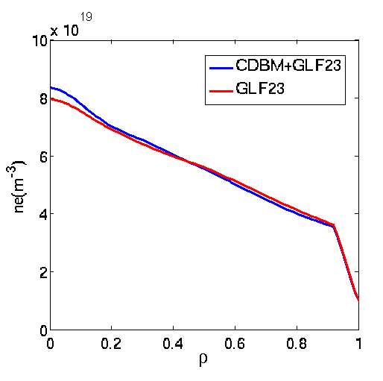

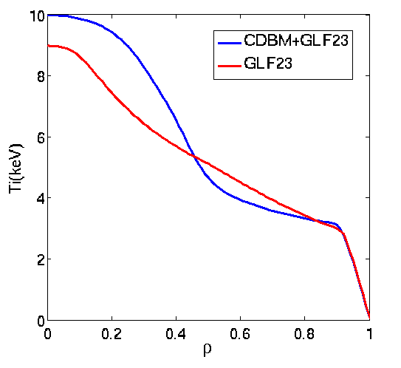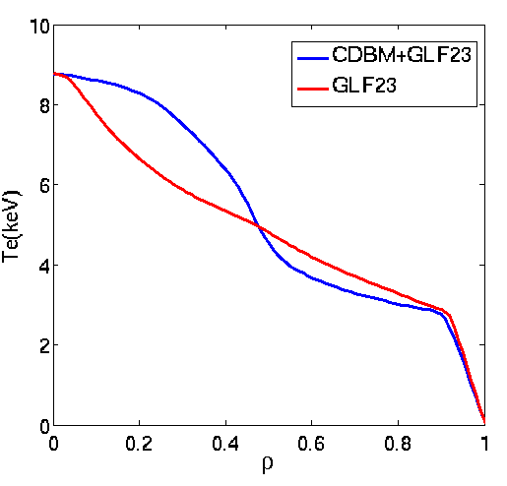

*Figure 21JT-60SA hybrid simulation densities (a) Electron temperature (b) Ion temperature(c) and total pressure (d) obtained with GLF23and CDBM (only for heat transport)*

The density, temperature and total pressure profiles for the hybrid scenarios obtained both with GLF23 and with CDBM are shown in figure 21. In both cases the density profiles is nearly identical with ne,ped=3.5x1019m-3 and <ne>=4.8x1019m-3 with fGr=0.6. These values are close to hybrid regimes obtained on JET. The pedestal width is slightly narrower than in the inductive scenario, ρ≈0.95, in both simulations. The temperature profiles for both simulations are slightly different, with lower temperature at the edge and higher temperature peaking in the core for the simulation with CDBM. However, in both cases, the average temperatures are similar. The pedestal pressure is also similar in both cases, Pped,GLF23=31kPa, Pped,CDBM=28kPa, and therefore the energy thermal confinement is similar H98(y,2)=1.15 for the simulation with GLF23 and H98(y,2)=1.20 for the CDBM one. In any case, for both simulations the typical high beta and high H98(y,2) factor, typical of hybrid regimes, are obtained.

However, these results highly depend on the pedestal pressure. In order to verify these predictions a PB ballooning analysis has been carried out.

|  |  |  |  |  |  |  |  |  |  |  |  |
| --- | --- | --- | --- | --- | --- | --- | --- | --- | --- | --- | --- |
| **Scenario** | **Bt (T)** | **Pin (MW)** | **Ip (MA)** | **q95** | **H98(y,2)** | **βN** | **fGr** | **<ne> x1019 m-3** | **<Te>keV** | **<Ti>keV** | **Pped(kPa)** |
| Inductive H-mode high density | 2.25 | 41 | 5.5 | 3.0 | 1.0 | 3.2 | 0.8 | 8.7 | 4.1 | 4.2 | 60 |
| Inductive H-mode low density | 2.25 | 41 | 5.5 | 3.1 | 1.0 | 3.6 | 0.6 | 6.5 | 5.7 | 6.6 | 70 |
| Hybrid GLF23 | 2.25 | 37 | 3.5 | 4.4 | 1.15 | 2.6 | 0.6 | 4.8 | 4.0 | 4.2 | 31 |
| Hybrid GLF23+CDBM | 2.25 | 37 | 3.5 | 4.4 | 1.20 |  | 0.6 | 4.7 | 4.1 | 4.5 | 28 |

*TABLE III Main results obtained forJT-60SA scenarios considered in this paper.*

**Conclusions**

An optimum simulation framework for the JT-60SA scenario modelling has been obtained by analyzing core turbulence and pedestal MHD characteristics of selected discharges from JT-60U and JET, which share characteristics with JT-60SA.

For inductive H-modes, for which ITG modes are found to be dominant in the core, heat and particle transport can be reasonably well simulated using the GLF23 transport model. The temperatures obtained are close to experimental data and the low density peaking, characteristic of these regimes is as also recovered.

However, for hybrid scenarios, the agreement between models and experimental data is less reliable. GLF23 tends to overestimate turbulence reduction by ExB shear leading to too high ion temperature profiles. Moreover, for plasma discharges, like the JT-60U 48158, in which TEM are dominant, it also overtimes the turbulence transport driven by these modes. Therefore, the application of this transport model in for those plasma conditions is doubtful. On the other hand, the CDBM transport model tends to give temperatures closer to experimental data in this regime, provided that the model is amended in order to take into account the high fast ion population typical of this scenario, which provides a significant reduction in turbulence. Regarding particle transport, GLF23 is able to reproduce the increase of density peaking usually obtained in these regimes.

The pedestal temperature has been predicted by using a scaling for the pedestal energy from 7. As the pedestal width is fixed therefore the pedestal temperature is calculated using (2). Simulations including particle and heat transport and pedestal pressure have been performed for JT-60U and JET inductive and hybrid discharges. In general the rms is below 20% for

**References**

[1]JT-60SA Research Plan -Research Objectives and Strategy Version 3.0 2011, December, http://www.jt60sa.org/pdfs/JT-60SA_Res_Plan.pdf

[2] Erba M. et al., Plasma Phys. Control. Fusion **39** 261 (1997).

[3] Honda M. et al., Nucl. Fusion 46 580 (2006).

[4] Kinsey J.E. et al.,Phys. Plasmas 12 052503(2005)

[5] Artaud J.F. et al.,Nucl. Fusion **50** 043001 (2010).

[6] Hayashi N. et al., Phys. Plasmas **17** 056112 (2010).

[7] CordeyJ. G. Nucl. Fusion **43** 670-674 (2003).

[8] Jenko F., Dorland W., Kotschenreuther M. and Rogers B.N., Phys. Plasmas 7, 1904 (2000).

[9]Hobirk J. et al., Plasma Phys. Control. Fusion **54** 095001 (2012).

[10] Oyama N. et al., Nucl. Fusion **49** 065026 (2009).

[11] Huysmans G.T.A. et al. CP90 Conference on Comp. Physics, Word Scientific Publ. Co. 1991, p.371.

[12] Belli E. A. andCandy J. Phys. Plasmas **17**, 112314 (2010)

[13] Romanelli F., Phys. Fluids B 1, 1018 (1989).

[14]RomanelliF. and BriguglioS. Phys. Fluids B **2**, 754 (1990).

[15]Staebler G. et al., «Testing the Trapped Gyro-Landau Fluid Transport Model with Data from Tokamaks and Spherical Tori»TH/P8-42, 22nd IAEA Fusion Energy Conference,

Geneva, Switzerland.

[16]Huysmans G.T.A. et al., Plasma Phys. Control. Fusion **8** 4292 (2001).

[17] Maget P. et al., Nucl. Fusion **53** 093011 (2013)

[18] Schneider M. et al.,Nucl. Fusion **51**, 063019 (2011).

[19] Tani K., et al., J. Phys. Soc. Jpn. **50,** 1726 (1981).

[20] Voitsekhovitch, I. et al., submitted to Nuc. Fusion.

[21]Staebler G. et al., Phys. Plasmas **12**, 102508 (2005).

[22] Garzotti L. et al., „Simulationsofdensityprofiles in JET hybrid discharges“ P1.004, 39th EPS Conference & 16th Int. Congress on Plasma Physics, Stockholm, Sweden

[23] Garcia J. and GiruzziG., Phys. Rev. Lett. **104**, 205003 (2010).

[24] Krivenski G.V. et al., Nucl. Fusion,**25** 127 (1985).